Problem
Part 1
In Part 1, the problem was to take the accelerometer data and display it in seconds instead of the recorded milliseconds. The output also needed to show the x, y, and z acceleration values, with certain formatting and decimal units of accuracy, the seconds had a similar constraint.
Part 2
In Part 2, the problem given to us was to write a function called mag() that would calculate the magnitude of the acceleration. This meant directing sensor inputs from the controller into a formulated equation used to find magnitude and <math.h> commands to write that formula.
Part 3
In Part 3, the task was to take the time given in milliseconds and format it into easier to read units. So it was asked to come up with functions to convert the time given into minutes, seconds, and milliseconds, with remainders for each one.
Part 4
In Part 4, the problem changed focus from the accelerometer to the controller’s buttons, specifically the ones with shapes. The goal was to write a new program that could count the amount of the four shaped buttons were being pressed at once. Solving the problem required creating a new function that returned this count without using scanf() or printf() inside of it as well as altering the while() function.

Analysis
Part 1
The input for Part 1 was milliseconds and the three acceleration values from the controller’s sensors. The output was “Echoing output: seconds and the accelerations”, all printed with precise formatting. This part seemed to be geared towards testing the ability to handle numerical formatting in C.
Part 2
The input for Part 2 was the same accelerometer values, but the output focused now on the acceleration values rather than the time, by finding the acceleration’s magnitide. The formula used was the square root of x squared plus y squared plus z squared. showing how mathematical functions can be used to process sensor data, as well as testing knowledge of <math.h>.
Part 3
For Part 3, the input was just the time in milliseconds, but we needed the output to be in minutes, seconds, and milliseconds, along with the previous magnitude. This required integer division and modulo operators to convert the time.
Part 4
In Part 4, the input was four integers representing pressing each of the four shaped buttons. The output was one integer that represented the total number of buttons pressed at once. This part focused on problem solving, by using outside knowledge to solve a problem in a unique fashion.

Design
Part 1
In Part 1, I used the provided code, while modifying the print statement to include specifiers that made sure to print the data in the specific character and digit parameters. I also divided the “t” variable by 1000.0 to convert them into seconds, creating a new double variable called seconds.
Part 2
In Part 2, I wrote the mag() function. It took three doubles as inputs and returned the square root of their squares added together. I included math.h at the top and used -lm when compiling so the math library would be linked correctly.
Part 3
In Part 3, I added three new functions: minutes(), seconds(), and millis(). Each one used integer division or modulus to return the correct part of the time. This made the output much easier to read and understand.
Part 4
In Part 4, I copied my previous program and but commented the old code and cleared the while variable. I made new variables for each one of the buttons, then I created a new function called "count_pressed()", that added up added up the four inputs, when they weren't zero. The main function read the inputs, sent them to the new function I made, and then printed the result.
Testing
Part 1
For Part 1, I tested by running the program and checking that the seconds displayed with three decimal places and that the accelerometer values matched the format requirements.
Part 2
For Part 2, I tested by moving the controller around and watching the magnitude. When the controller was still, the magnitude was close to one, and when I tilted it, the value changed as expected.
Part 3
For Part 3, I tested by letting the program run long enough to produce large millisecond values. I confirmed that values like 129313 ms were properly displayed as 2 minutes, 9 seconds, and 313 milliseconds.
Part 4
For Part 4, I tested by pressing different combinations of the shape buttons. The output showed 0 when no buttons were pressed, 1 or 2 when one or two buttons were pressed, and 4 when all four buttons were pressed at the same time.

Comments
Through all four parts of the lab, I learned practical ways to use functions, as well as truly learning how much more organized they make code. I also became a little more comfortable with using format specifiers and the math library. Part 4 was very interesting, I was extremely confused at first on how to solve it, which is when I turned to google for some help which taught me what the “!” (not) operator was. But when I talked with the TA’s I found that I used a different method from most, most used “if/else”, I wish I used this because I feel it would’ve been a lot easier and more useful.

Implementation
The following shows my completed code for lab3.c (Parts 1–3):
#include <stdio.h>
#include <math.h>
double mag(double x, double y, double z) {
return sqrt(x*x + y*y + z*z);
}
int minutes(int t) {
return t / 60000;
}
int seconds(int t) {
return (t / 1000) % 60;
}
int millis(int t) {
return t % 1000;
}
int main(void) {
int t;
double ax, ay, az;
while (1) {
scanf("%d,%lf,%lf,%lf", &t, &ax, &ay, &az);
/* CODE SECTION 0 */
double seconds = t / 1000.0;
printf("Echoing output: %8.3f, %7.4f, %7.4f, %7.4f\n", seconds, ax, ay, az); */
/* CODE SECTION 1 */
printf("At %d ms, the acceleration's magnitude was: %lf\n",
t, mag(ax, ay, az));
/* CODE SECTION 2 */
printf("At %d minutes, %d seconds, and %d milliseconds it was: %lf\n",
minutes(t), seconds(t), millis(t), mag(ax,ay,az));
}
return 0;
}
The following shows my completed code for lab3-2.c (Part 4):
#include <stdio.h>
#include <math.h>
int count_pressed(int triangle, int circle, int cross, int square) {
return (triangle != 0) + (circle != 0) + (cross != 0) + (square != 0);
}
int main(void) {
int tri, cir, cro, squ;
while (1) {
if (scanf("%d,%d,%d,%d", &tri, &cir, &cro, &squ) != 4) {
continue;
}
printf("%d\n", count_pressed(tri, cir, cro, squ));
fflush(stdout);
}
return 0;
}
Output
Part 1:
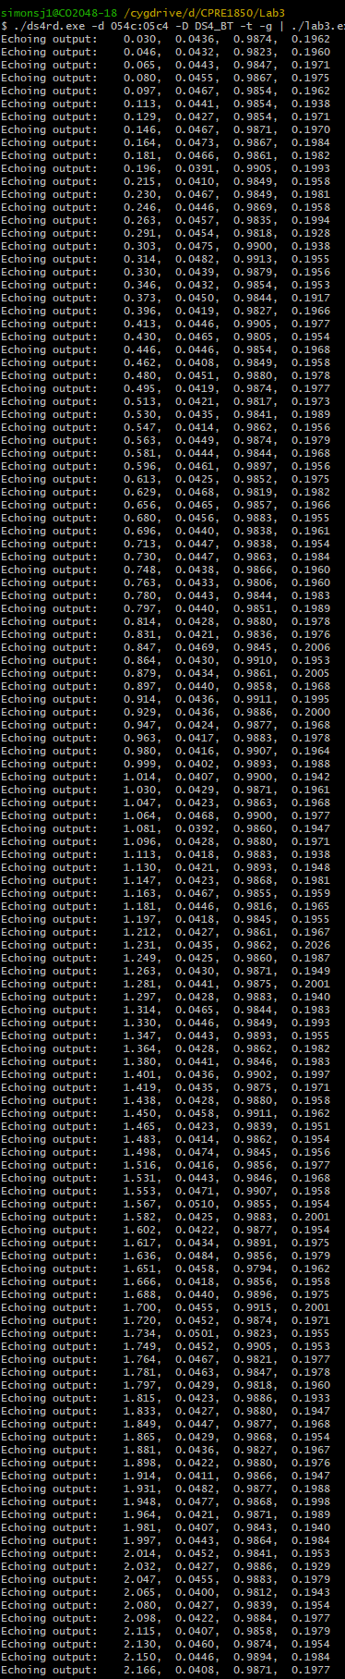
Part 2:
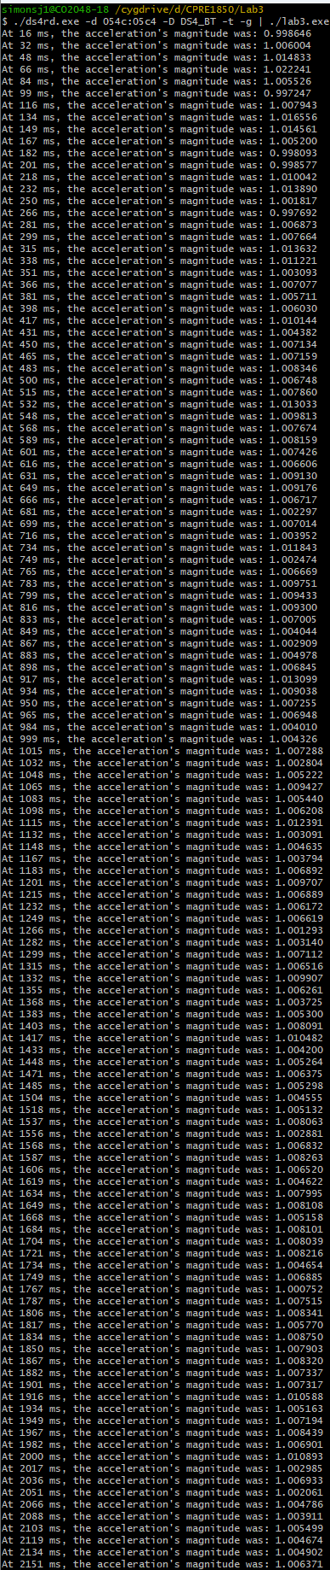
Part 3:
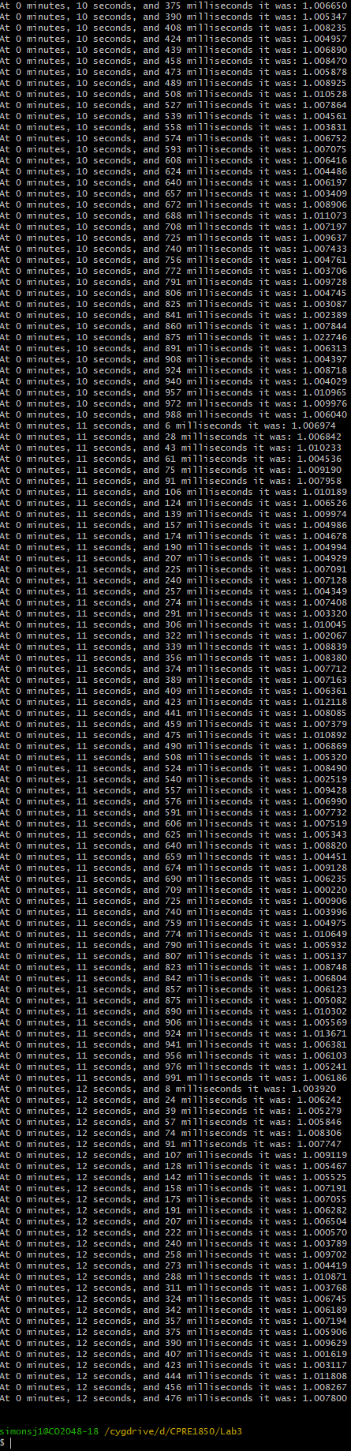
Part 4:
0
0
0
0
0
0
0
1
1
1
1
1
1
1
1
1
1
1
1
1
1
1
1
1
1
1
1
1
1
1
1
1
1
1
1
1
1
1
1
2
2
2
2
2
2
2
2
2
2
2
2
2
2
2
2
2
2
2
2
2
2
3
3
3
3
3
3
3
3
3
3
3
3
3
3
3
3
3
3
3
3
3
3
3
4
4
4
4
4
4
4
4
4
4
4
4
4
4
4
4
4
4
4
4
4
4
4
4
4
4
4
4
4
4
4
4
4
4
4
4
4
4
4
4
4
4
4
4
4
4
2

